**Q ) Arithmetic operations in express**

const express = require('express');

const app = express();

app.get('/add/:num1/:num2', (req, res) => {

const num1 = parseInt(req.params.num1);

const num2 = parseInt(req.params.num2);

const sum = num1 + num2;

res.send(`Sum of ${num1} and ${num2} is ${sum}`);

});

app.get('/subtract/:num1/:num2', (req, res) => {

const num1 = parseInt(req.params.num1);

const num2 = parseInt(req.params.num2);

const difference = num1 - num2;

res.send(`Difference of ${num1} and ${num2} is ${difference}`);

});

app.get('/multiply/:num1/:num2', (req, res) => {

const num1 = parseInt(req.params.num1);

const num2 = parseInt(req.params.num2);

const product = num1 * num2;

res.send(`Product of ${num1} and ${num2} is ${product}`);

});

app.get('/divide/:num1/:num2', (req, res) => {

const num1 = parseInt(req.params.num1);

const num2 = parseInt(req.params.num2);

if (num2 === 0) {

res.status(400).send('Division by zero is not allowed');

} else {

const quotient = num1 / num2;

res.send(`Quotient of ${num1} and ${num2} is ${quotient}`);

}

});

const PORT = 3000;

app.listen(PORT, () => {

console.log(`Server running on port ${PORT}`);

});

**OUTPUT:**

**Q ) Demonstration of get method**

const express = require('express');

const app = express();

app.get('/', (req, res) => {

res.send('Hello, welcome to the GET method demonstration!');

});

app.get('/greet', (req, res) => {

const name = req.query.name || 'Anonymous';

res.send(`Hello, ${name}!`);

});

const PORT = 3000;

app.listen(PORT, () => {

console.log(`Server running on port ${PORT}`);

});

**OUTPUT:**



**Q ) Demonstration Post method**

const express = require('express');

const bodyParser = require('body-parser');

const app = express();

app.use(bodyParser.urlencoded({ extended: false }));

app.use(bodyParser.json());

app.get('/form', (req, res) => {

res.send(`

<form action="/submit" method="post">

<label for="email">Email:</label>

<input type="email" id="email" name="email" required><br>

<label for="password">Password:</label>

<input type="password" id="password" name="password" required><br>

<button type="submit">Submit</button>

</form>

`);

});

app.post('/submit', (req, res) => {

const { email, password } = req.body;

res.send(`Email: ${email}, Password: ${password}`);

});

const PORT = 3000;

app.listen(PORT, () => {

console.log(`Server running on port ${PORT}`);

});

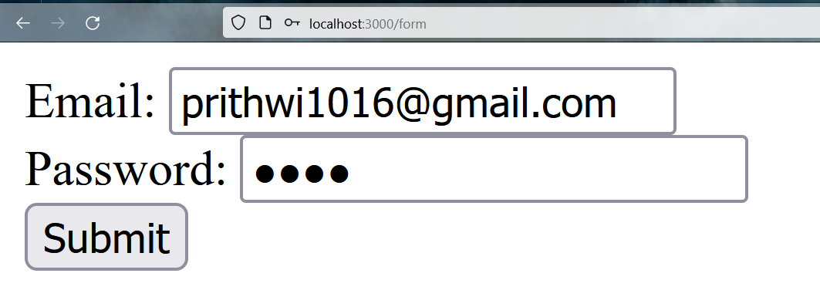**OUTPUT:**

**After Clicking Submit:-**

